**Description of changes in pheasant densities over time**

We use data from 846 pheasants, released at 18 sites, that were tracked for up to eight months (July-February) to describe month-by-month patterns of mortality, distance dispersed from the release site and densities in the surrounding area. The fixes that were recorded gave us data on the location of the bird, it’s distance from the release point and the time that it spent at that distance, and whether the bird was alive or dead. These records came from three separate datasets (Table X). First, 250 pheasants (123 male, 127 female) were tracked at a single site in mid Devon at high spatial and temporal resolution using a reverse GPS tracking system, ATLAS, described and validated in Beardsworth et al. (2022). The tracking system was installed for a series of other studies (e.g. Beardsworth et al. 2021a,b, Heathcote et al. 2023) and data was collected form the site over two seasons 2017-18 and 2018-19. Locations were recorded remotely at 1/4Hz with pooling of locations to improve spatial accuracy at the expense of temporal resolution such that we obtained locations every five minutes. Birds were fitted with a backpack tap (22g) and released when ~9-10 weeks old. The site was a research farm where birds were released from a single, central woodland pen from where they could disperse freely into an area containing ~40 artificial feeders. For the first two months post-release, birds were driven back towards the release pen at dusk (aka dogging in – GCT 1996). There was no predator control on the site nor any game shooting. However, shooting of game and predators occurred on neighbouring farms. Second, 110 pheasants were tracked at 11 sites in northern England using XXX GPS tags as part of a study by APHA specifically to explore the movement and survival of released pheasants. The study was conducted for one year at each site in either 2022 or 2023. At each site, 10 birds were fitted with a backpack tag (XXg) and released from a single woodland pen when XX weeks old. Locations were recorded each hour during both daylight and the night. The sites were operating game shoots that had agreed to participate in the study and where a variety of gamekeeping management techniques were used including artificial feeding, dogging in and predator control. [Due to privacy concerns] we have no data on specific levels of these actions at each site. Third, 486 pheasants were tracked at six sites in southern England using VHF radio tags that were located manually as part of a PhD study into the management of released gamebirds (Turner 2007). The study was conducted over two years with a new cohort of birds released when ~7 weeks old and tracked before and during the game shooting season. Attempts were made to locate each bird at least twice a week but other locations were also collected where possible. The sites were operating game shoots that had agreed to participate in the study and where a variety of gamekeeping management techniques were used including artificial feeding, dogging in and predator control.

|  |  |  |  |
| --- | --- | --- | --- |
| Study/Site | Year of release | Number of pheasants tracked | Median location frequency |
| Mid Devon site | 2017 | 124 | 5 minutes |
| Mid Devon site | 2018 | 126 | 5 minutes |
| North England sites 1 - 11 | 2023 | 110 | 60 minutes |
| Berkshire site (f) | 2001 | 27 | 2 days |
| Hampshire site 1 (b) | 2001 | 24 | 2 days |
| Wiltshire site (cf) | 2001 | 30 | 2.1 days |
| Hampshire site 2 (cr) | 2001 | 30 | 2.1 days |
| Dorset site (h) | 2001 | 29 | 2.8 days |
| Hampshire site 3 (w) | 2001 | 25 | 2 days |
| Berkshire site (f) | 2002 | 24 | 2.1 days |
| Hampshire site 1 (b) | 2002 | 25 | 2.1 days |
| Wiltshire site (cf) | 2002 | 28 | 2.4 days |
| Hampshire site 2 (cr) | 2002 | 29 | 2.4 days |
| Dorset site (h) | 2002 | 30 | 2.1 days |
| Hampshire site 3 (w) | 2002 | 27 | 2.1 days |
| Berkshire site (f) | 2003 | 24 | 2.1 days |
| Hampshire site 1 (b) | 2003 | 25 | 2.2 days |
| Wiltshire site (cf) | 2003 | 29 | 2.1 days |
| Hampshire site 2 (cr) | 2003 | 27 | 4.7 days |
| Dorset site (h) | 2003 | 28 | 2.9 days |
| Hampshire site 3 (w) | 2003 | 25 | 2.1 days |

**Table 1** Numbers of pheasants tracked in each year in each cohort at sites participating in the three studies.

*Determining Mortality*

Determining mortality from tracking data is not straightforward (Sergo et al. 2019). In some cases, we could locate the carcass, either because we could search at the last known location (ATLAS and GPS systems) or we could search for VHF tags equipped with mortality switches when these were activated. However, sometimes were found without the bird and it was difficult to confirm whether they had been shed by a live bird or had been torn form a dead bird by the predator and discarded. In other cases, tags were assumed to have malfunctioned, and the bird being tracked was lost. The probabilities of each of these fates occurring likely differed between the studies (due to the different equipment and attachments being used) and between sites (due to different habitats making locating lost tags differentially difficult). Therefore, we used a single metric to assign a mortality date. We took the last day on which a definite signal of life (movement between locations on consecutive fixes) was recorded as the day of death. Given the high temporal resolution of the ATLAS and GPS system, we are confident that our assigned mortality days are accurate to within 24 hours. For the VHF tracking data, average intervals between fixes were 2.35 days and thus our precision of mortality is likely to be accurate to the nearest 2-3 days. For each cohort of birds, we calculated how many birds were still alive on the last day of the month, what proportion of the original number of birds were still alive, and what the mortality rate for the month was.

Figure 1 – the proportion of tracked birds left alive at the start of each month, in each of the three tracking datasets.

*Determining Distribution*

The effects of an animal in a particular location are likely to be related to the time that they spend there [REF?]. Therefore, it is not sufficient to simply consider that an animal has occupied, or passed through, an area but instead it is of interest how long they stayed there. To determine the distribution of tracked pheasants, we divided the landscape surrounding each of the release pens into 9 concentric distance bands: 0 – 250m, 250 – 500m, 500 – 750m, 750 – 1000m, 1000 – 1250m, 1250 – 1500m, 1500 – 1750m, 1750 – 2000m, 2000m+. Because the location fix rate varies across each data set, we converted the number of location fixes in each of these 9 distance bands to a proportion of the total number of fixes. This was done by dividing the number of location fixes that fell within each distance band in each month by the total amount of location fixes across all distance bands and months. This metric incorporates the mortality of the tracked pheasants (the proportion of location fixes will be lower in a month where fewer birds are alive to contribute to the location fixes), yet still compensates for the varying location fix rate across the tracking data sets.

*Determining Density*

Many of the negative effects of released gamebirds are dependent on the density of the birds (e.g. Sage et al. 2005a, Gortazar et al. 2006, Pressland 2009, Neumann et al. 2015 Porteus 2015 and Capstick et al. 2019 but see Davey 2008). The focus of this work has been on the density of birds within woodland release pens, but such effects may extend into the wider environment if high densities occur there, either due to the sheer number of birds released and/or clustering of birds around resource patches e.g. artificial feeders or cover. Based on the work in woodland pens, the Code of Good Shooting Practice (https://www.codeofgoodshootingpractice.org.uk/) advises that pheasants in woodland pens should not be released at densities greater than 1000/Ha or 700/Ha in ancient semi-natural woodland. Above these levels, negative effects in and immediately around the pen are detected. As birds disperse further from the release point, the total area that they might occupy increases and thus the density of birds in that area decreases. To determine density of released pheasants we took the proportion of location fixes in each of the 9 distance bands in each month and divided them by the area of the distance band (e.g. the 0-250m band surrounding the pen would occupy 19.6Ha, the 1750-2000m band would occupy 294.5Ha). The area of the 2000m+ distance band was 23,327Ha as this is the area of a distance band ranging from 2000m to 8846m, which was the furthest from the release pen we observed any pheasant ranging. By correcting the proportion of location fixes (which accounts for bird mortality and varying fix rate) for the area of distance bands over which they are summed, we have a metric describing the predicted ecological impact of released pheasants in each distance band. Because this metric occupies a range between $0$ and $0.015$, we have also transformed this metric by dividing by the maximum value to emphasise the changes in this metric. The metric can be thought of as ratio of the most severe ecological change wrought by released pheasants (in and around the release pen in August), per Ha. We hereafter refer to this metric as a PEC unit (unit of Pheasant Ecological Change). [different detection probabilities across distance bands across datasets]

**RESULTS**

The local densities of released pheasants changed markedly throughout the season due to their dispersal and death (Fig 2). At release, 99.7% of monthly location fixes were within 250m of the release pen. In the first month after release (August), when gamekeepers typically make much effort to retain birds in the immediate vicinity of the release pen, 1 PEC units were within 500m of the release pen respectively (Fig 2 –August). Only 0.001% of monthly records were beyond 500m at this stage. By December, birds had started to disperse as shooting induced disturbance and gamekeepers either actively attempted to move birds to drives further from the release pen and/or reduced efforts to retain birds in the pen. At this stage, 82.2% of monthly records were within 250m of the release pen, with 0.08 PEC units within 500m of the release pen (Fig 2 - December). Now, 12.1% of monthly records were beyond 500m at this stage with PEC units in the bands beyond 500m being 0.0007, 0.0004, 0.0002, 0.00005, 0.000006, 0.00006 and 0.00000009. By February, when the shooting season had ended and so too much gamekeeping effort to direct and retain birds, 54% of all records were within 500m of the release pen, with 0.04 PEC units within 500m of the release pen (Fig 2 - February). At this point, 11.5% of records were beyond 500m at this stage with PEC units in the distance bands beyond 500m being 0.009, 0.001, 0.0004, 0.002, 0.0006, 0, and 0.7% of location fixes were beyond 2000m where they comprised 0.001 PEC units.

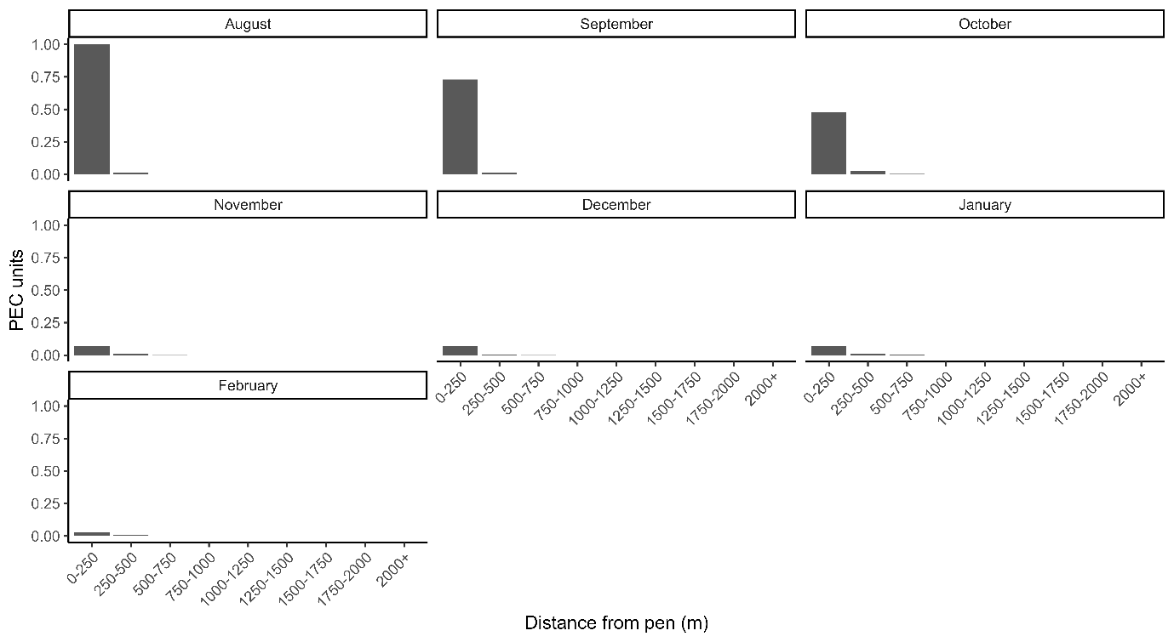

Figure 2- bars showing the number of Pheasant Ecological Change (PEC) units in each distance band in each month for which we have tracking data. PEC units are calculated as the proportion of total location fixes per hectare, divided by the highest proportion of total location fixes per hectare (August, 0-250m).

**DISCUSSION**

When do effects fall below recommended densities of 700/Ha? How precautionary can we be? What release numbers might lead to these densities outside the pen (see Neuman et al. 2015, Pressland 2009, Hall et al. 2021)

Relate to GL43 – what are the expected numbers of birds moving >500m and so potentially entering Pas? Consider that Pas generally do not surround release points, so consider only a portion of birds moving this far would actually enter the PA. Give range. Comment on alternative GL43 distances (250, 500, 1000, 2000 – see RSPB response to DEFRA consultation, or 5000 – see Wild Justice call in judicial review).

Effect of neighbouring pens/shoot on densities at a distance – tessellate and assume 6 surrounding pens at 500m and calculate max possible densities. Can we get data on pen locations/densities from APHA or other sources?

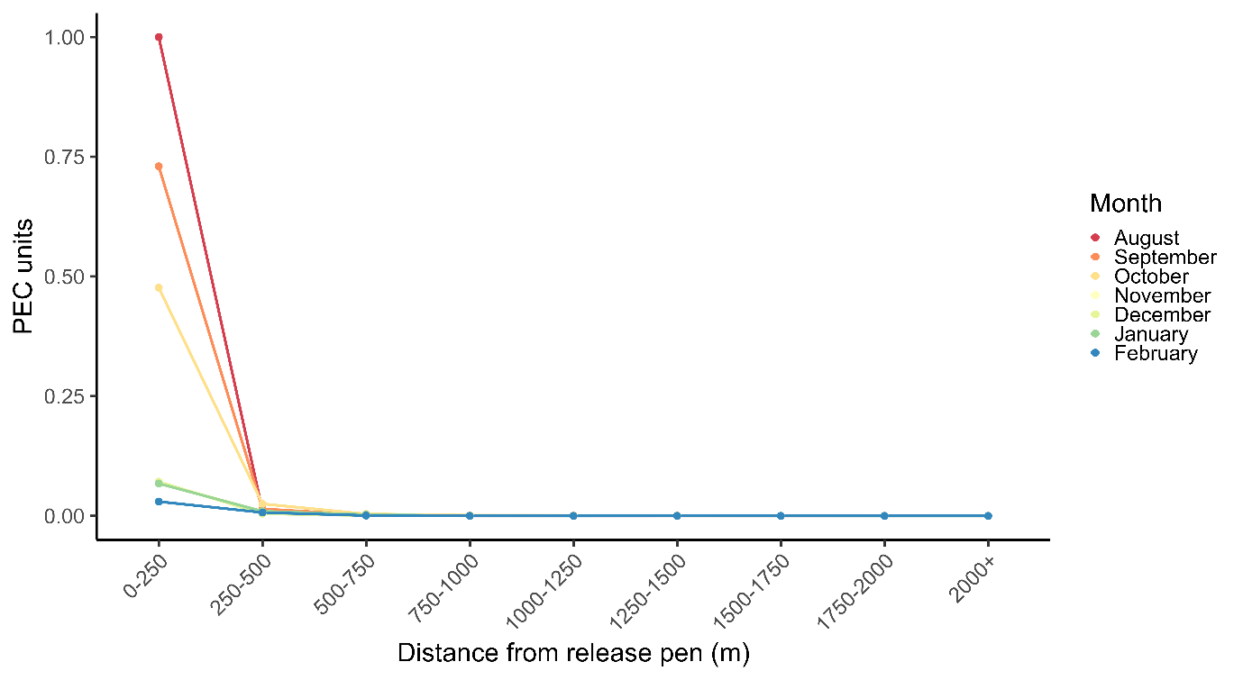

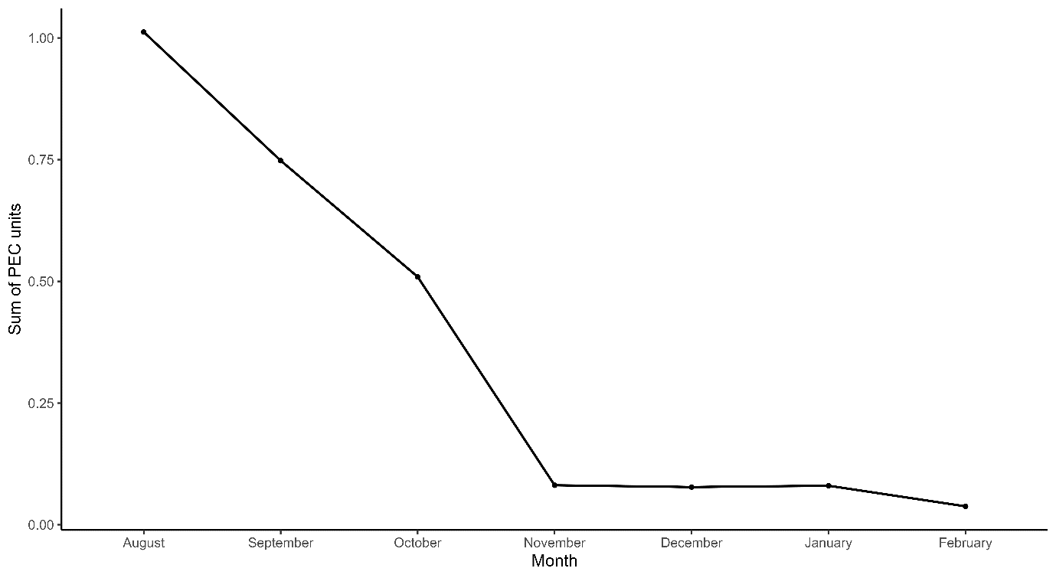

**REFERENCES**

Beardsworth, C. E., Whiteside, M. A., Laker, P. R., Nathan, R., Orchan, Y., Toledo, S., ... & Madden, J. R. (2021). Is habitat selection in the wild shaped by individual‐level cognitive biases in orientation strategy?. *Ecology Letters*, *24*(4), 751-760.

Beardsworth, C. E., Whiteside, M. A., Capstick, L. A., Laker, P. R., Langley, E. J., Nathan, R., ... & Madden, J. R. (2021). Spatial cognitive ability is associated with transitory movement speed but not straightness during the early stages of exploration. *Royal Society Open Science*, *8*(3), 201758.

Beardsworth, C. E., Gobbens, E., van Maarseveen, F., Denissen, B., Dekinga, A., Nathan, R., ... & Bijleveld, A. I. (2022). Validating ATLAS: A regional‐scale high‐throughput tracking system. *Methods in Ecology and Evolution*, *13*(9), 1990-2004.

Heathcote, R. J., Whiteside, M. A., Beardsworth, C. E., Van Horik, J. O., Laker, P. R., Toledo, S., ... & Madden, J. R. (2023). Spatial memory predicts home range size and predation risk in pheasants. *Nature Ecology & Evolution*, *7*(3), 461-471.

Otis, D. L., & White, G. C. (1999). Autocorrelation of location estimates and the analysis of radiotracking data. *The Journal of Wildlife Management*, 1039-1044.

Sergio, F., Tanferna, A., Blas, J., Blanco, G., & Hiraldo, F. (2019). Reliable methods for identifying animal deaths in GPS‐and satellite‐tracking data: Review, testing, and calibration. *Journal of Applied Ecology*, *56*(3), 562-572.